

THE UNIVERSITY OF AZAD JAMMU AND KASHMIR, MUZAFFARABAD
Department of Software Engineering

Submitted to: | Engr. Sidra Rafique
Course Title: | Data Structure and Algorithm
Course Code: | CS-2101
Session: | 2024-2028
Lab No: | 05
Roll No: | 2024-SE-15
Submitted By: | Shahzad Ahmed Awan
Submission date: | November 29, 2025
Table of Contents
Lab 05 – Circular Linked List Implementation 3
1. Objective 3
2. Background 3
Advantages: 3
Disadvantages: 4
3. Algorithm 4
3.1 Singly Circular Linked List 4
3.2 Doubly Circular Linked List 4
4. Source Code Explanation 5
4.1 Singly Circular Linked List 5
4.2 Doubly Circular Linked List 7
5. Output Screenshots 9
5.1 Singly Circular Linked List 9
5.2 Doubly Circular Linked List 9
6. Conclusion 10
7. Reflection 10

Table of Figures
Figure 1: A Diagram Demonstrating Singly Circular Linked List 3
Figure 2: A Diagram Demonstrating Doubly Circular Linked List 3
Figure 3: Source Code for Singly Circular Linked List using OOP (Screenshot -1) 5
Figure 4: Source Code for Singly Circular Linked list using OOP (Screenshot -2) 6
Figure 5: Source Code for Doubly Circular Linked List using OOP (Screenshot- 1) 7
Figure 6: Source Code for the Doubly Circular Linked List (Screenshot- 2) 8
Figure 7: Output for the Singly Circular linked List Code 9
Figure 8: Output for the Doubly linked List Code 9

Lab 05 – Circular Linked List Implementation

1. Objective
To implement Singly Circular Linked List (SCLL) and Doubly Circular Linked List (DCLL) in C++ to perform insertion, deletion, and traversal operations, demonstrating circular linking and bidirectional traversal.

2. Background
- Singly Circular Linked List:
  - Each node points to the next node.
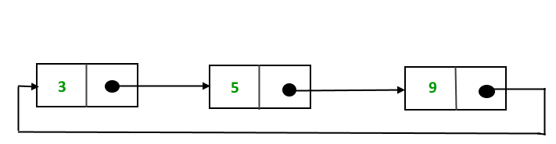
  - The last node points back to the head, forming a circular structure.
Figure 1: A Diagram Demonstrating Singly Circular Linked List

- Doubly Circular Linked List:
  - Each node contains next and prev pointers.
  - Tail node points to head, and head’s prev points to tail.
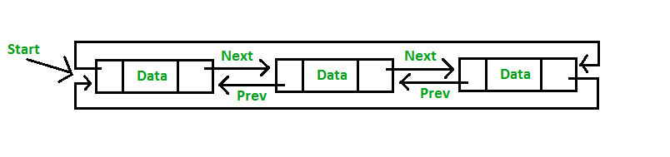
  - Enables bidirectional traversal.
Figure 2: A Diagram Demonstrating Doubly Circular Linked List

Advantages:
- Efficient insertion/deletion at both ends.
- Traversal possible in both directions.

Disadvantages:
- Requires extra memory for prev pointer.
- Slightly more complex than singly linked list.

3. Algorithm

3.1 Singly Circular Linked List
- Start the program.
- Define a Node structure with data and next pointer.
- Implement functions:
  - insertEnd() – Insert node at the end.
  - display() – Print circular list starting from head.
- Insert sample nodes and display the list.
- End program.

3.2 Doubly Circular Linked List
- Start the program.
- Define Node structure with data, prev, and next.
- Create DoublyCircularList class with head and tail.
- Implement functions:
  - insertAtBeginning() – Insert node at start.
  - insertAtEnd() – Insert node at end.
  - deleteFromBeginning() – Remove first node.
  - deleteFromEnd() – Remove last node.
  - displayForward() – Traverse head → tail.
  - displayBackward() – Traverse tail → head.
- Use a menu loop for repeated operations.
- End program.

4. Source Code Explanation

4.1 Singly Circular Linked List
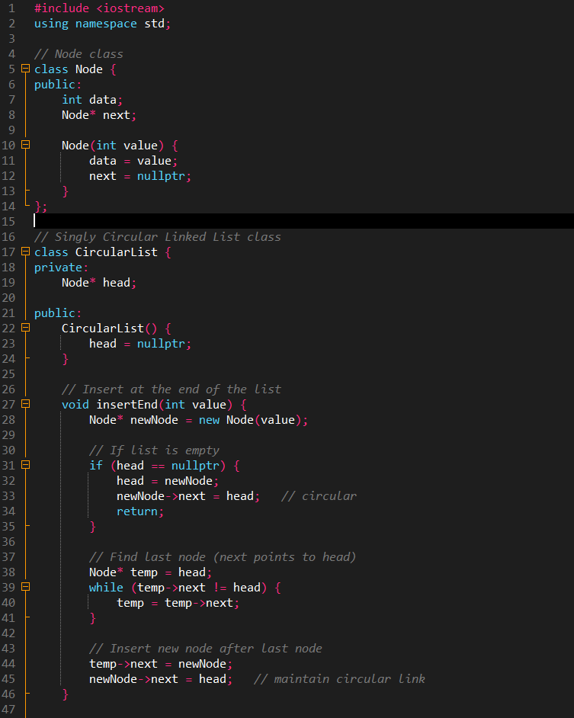
Figure 3: Source Code for Singly Circular Linked List using OOP (Screenshot -1)

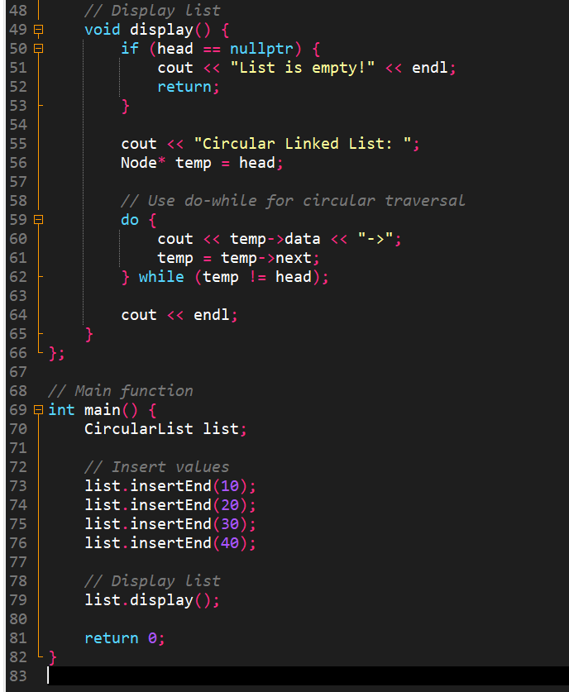
Figure 4: Source Code for Singly Circular Linked list using OOP (Screenshot -2)

- insertEnd(): Adds a node after last node; points it back to head.
- display(): Traverses from head until it returns to head.

4.2 Doubly Circular Linked List
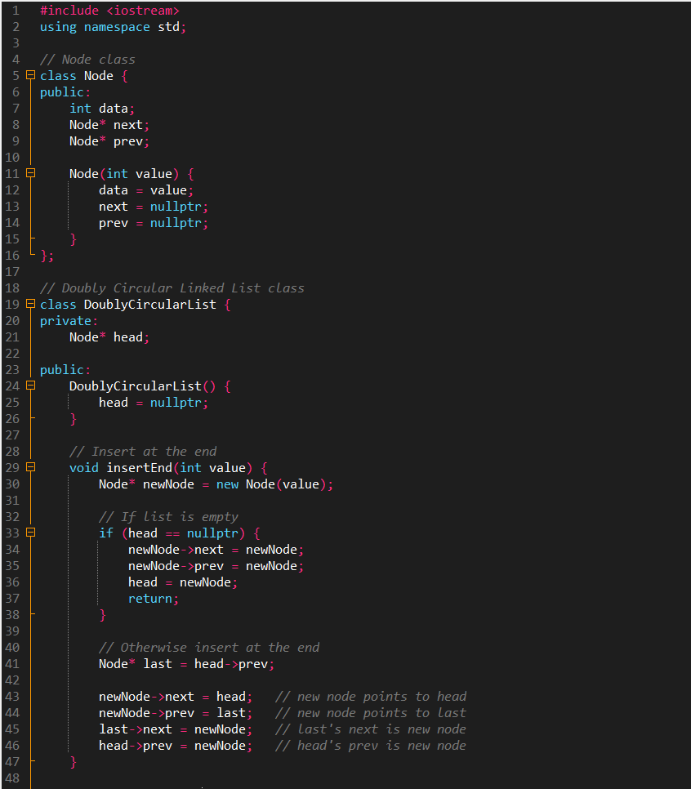
Figure 5: Source Code for Doubly Circular Linked List using OOP (Screenshot- 1)
• insertEnd() – Adds a new node at the end by linking it between the last node and the head, keeping both next and prev circular.
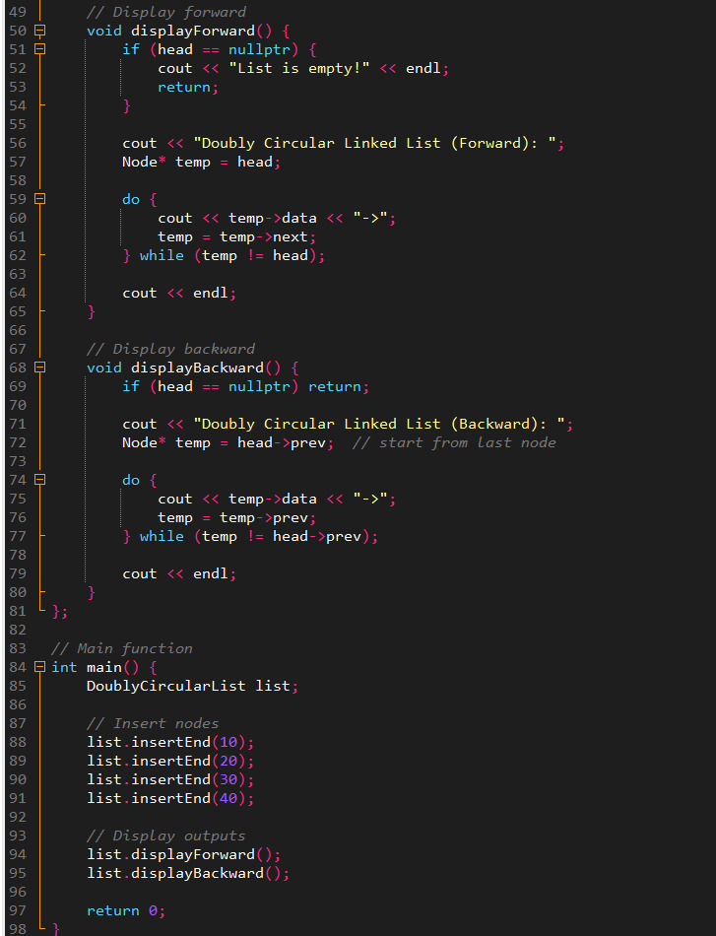
Figure 6: Source Code for the Doubly Circular Linked List (Screenshot- 2)
• displayForward() – Prints the list from head to tail using next pointers.
• displayBackward() – Prints the list from tail to head using prev pointers.
displayBackward(): Prints tail → head.
Menu loop: Handles multiple operations with screen refresh.

5. Output Screenshots

5.1 Singly Circular Linked List
Expected Output:
Circular Linked List: 10 20 30 40

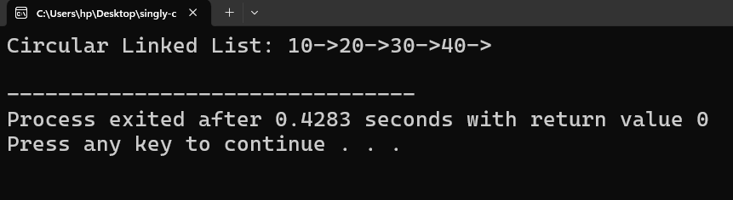
Figure 7: Output for the Singly Circular linked List Code

5.2 Doubly Circular Linked List
Expected Output:
Forward: 10 -> 20 -> 30 -> 40
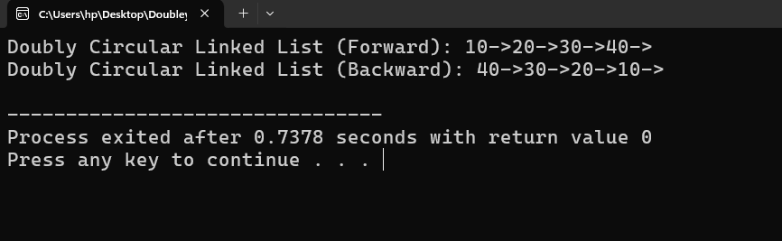
Backward: 40 -> 30 -> 20 -> 10
Figure 8: Output for the Doubly linked List Code

6. Conclusion
- Successfully implemented SCLL and DCLL with insertion, deletion, and traversal operations.
- Demonstrated circular linking, pointer manipulation, and bidirectional traversal in C++.

7. Reflection
- Improved understanding of dynamic memory and pointers.
- Learned differences between singly and doubly circular structures.
- Menu-driven operations improve user interactivity and readability.

